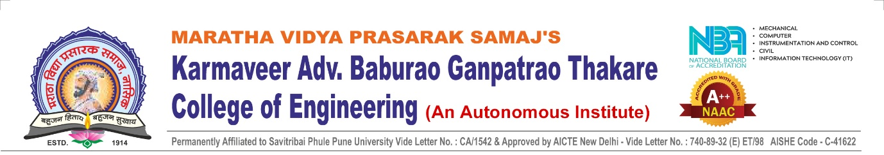
HACKATHON CODE OF CONDUCT
1. Purpose
KBT Anvinyathon is committed to providing a safe, inclusive, respectful, and professional environment for all participants, mentors, judges, sponsors, and organizers.
This Code of Conduct defines expected behaviour and ethical standards to ensure a positive and productive hackathon experience.

2. Expected Behavior
All participants, mentors, judges, volunteers, and organizers are expected to:
- Treat everyone with respect, dignity, and fairness.
- Communicate professionally and courteously.
- Be open to diverse viewpoints and ideas.
- Maintain honesty and academic integrity.
- Follow all instructions and guidelines provided by the organizing committee.
- Work collaboratively and responsibly within their teams.

3. Unacceptable Behavior
The following behaviors will not be tolerated:
- Harassment, discrimination, or intimidation in any form.
- Offensive remarks related to gender, religion, caste, race, region, or background.
- Plagiarism, copying, cheating, or misrepresentation of work.
- Disruptive behavior that interferes with the smooth conduct of the event.
- Use of abusive language or inappropriate content.
- Any form of misconduct affecting other participants or event management.

4. Academic & Ethical Integrity
- All projects must be original and developed during hackathon hours.
- Pre-built or previously submitted projects are strictly prohibited.
- Open-source tools and APIs are allowed with proper attribution.
- Violation of intellectual property rights will lead to immediate disqualification.

5. Compliance with Hackathon Rules
- Participants must adhere to all timelines, submission guidelines, and evaluation procedures.
- Failure to comply with official instructions may result in penalties.
- Organizers reserve the right to inspect project progress if required.

6. Reporting Violations
- Any participant witnessing misconduct should immediately report it to the organizing committee.
- Reports will be handled confidentially and investigated fairly.
- Appropriate action will be taken based on the severity of the violation.

7. Consequences of Violations
Violation of this Code of Conduct may result in:
- Verbal or written warning
- Deduction of evaluation marks
- Disqualification from the hackathon
- Removal from the event venue
- Cancellation of participation certificate

8. Final Authority
All decisions taken by the Organizing Committee regarding discipline, evaluation, and conduct shall be final and binding.

📌 Declaration
By registering for KBT Anvinyathon, participants agree to abide by this Code of Conduct and all hackathon rules.

